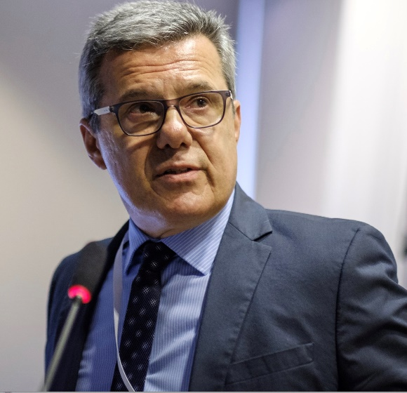

Name and Surname |  | Apostolos Athanasiadis
Affiliation |  | Surgical Section of the Medical School, Aristotle University of Thessaloniki, Greece
Date and place of birth |  | September 29, 1956 Thessaloniki, Greece
Titles |  | MD, Professor in Obstetrics Gynecology Maternal Fetal Medicine, Chairman, Director
Short CV:  Education and training  Work experience |  | 1980 MD Aristotle University, Thessaloniki, Greece  1998-1999 Fellowship in maternal and fetal medicine, Maternal Fetal Medicine Unit, Department of Obstetrics and Gynecology, Yale University, USA  2016-Now Chairman of the 3rd Department Obstetrics and Gynecology Medical School, Aristotle University of Thessaloniki, Greece  2019-2021 Director of the Surgical Section of the Medical School of Aristotle University of Thessaloniki, Greece
Scientific International Society Memberships |  | Founding member South East European Society of Perinatal Medicine (SEEPM)  2013-2015 President SEEPM  Associate Fellow International Academy of Perinatal Medicine (IAPM)  Executive Board European Association of Perinatal Medicine (EAPM)
Scientific National Society Memberships |  | 2020-2022 President Obstetrics and Gynecology Society of Thessaloniki, Greece  2018-2020 Immediate past President Hellenic Society on Ultrasound in Obstetrics and Gynecology  2002-2004 President Hellenic Society of Perinatal Medicine  2019-2021 Member of the Executive Board Hellenic Society of Obstetrics and Gynecology
Recognitions |  | 2009 Ayash Saban Sifai Scientific Award  2011 Soranos Scientific Award  2016 Grand Dr Papanicolaou award, New York, USA  2020 Hippocratic award, New York, USA  Honorary Member Romanian Society of Perinatal Medicine  Honorary Member Romanian Society of Ultrasound in Obstetrics and Gynecology  Visiting Professor at the Weill Cornell Medical College USA  Visiting Professor European University Cyprus  Visiting Professor Zucker School of Medicine at Hofstra Northwell New York, USA
Publications and scientific activities |  | Published more than 200 scientific papers, presentations, articles and chapters  Have been cited more than 1800 times in the Science Citation Index  Invited speaker with more than 350 lectures at iinternational and Greek congresses and meetings  Successfully contributed in organizing many congresses and courses in Europe as president, member of the organizing committees and scientific coordinator  Main scientific interests are: fetal medicine, prenatal diagnosis, 3D and 4D ultrasonography and metabolomics in pregnancy
Other

