PERSONAL INFORMATION | Georgios Papazisis
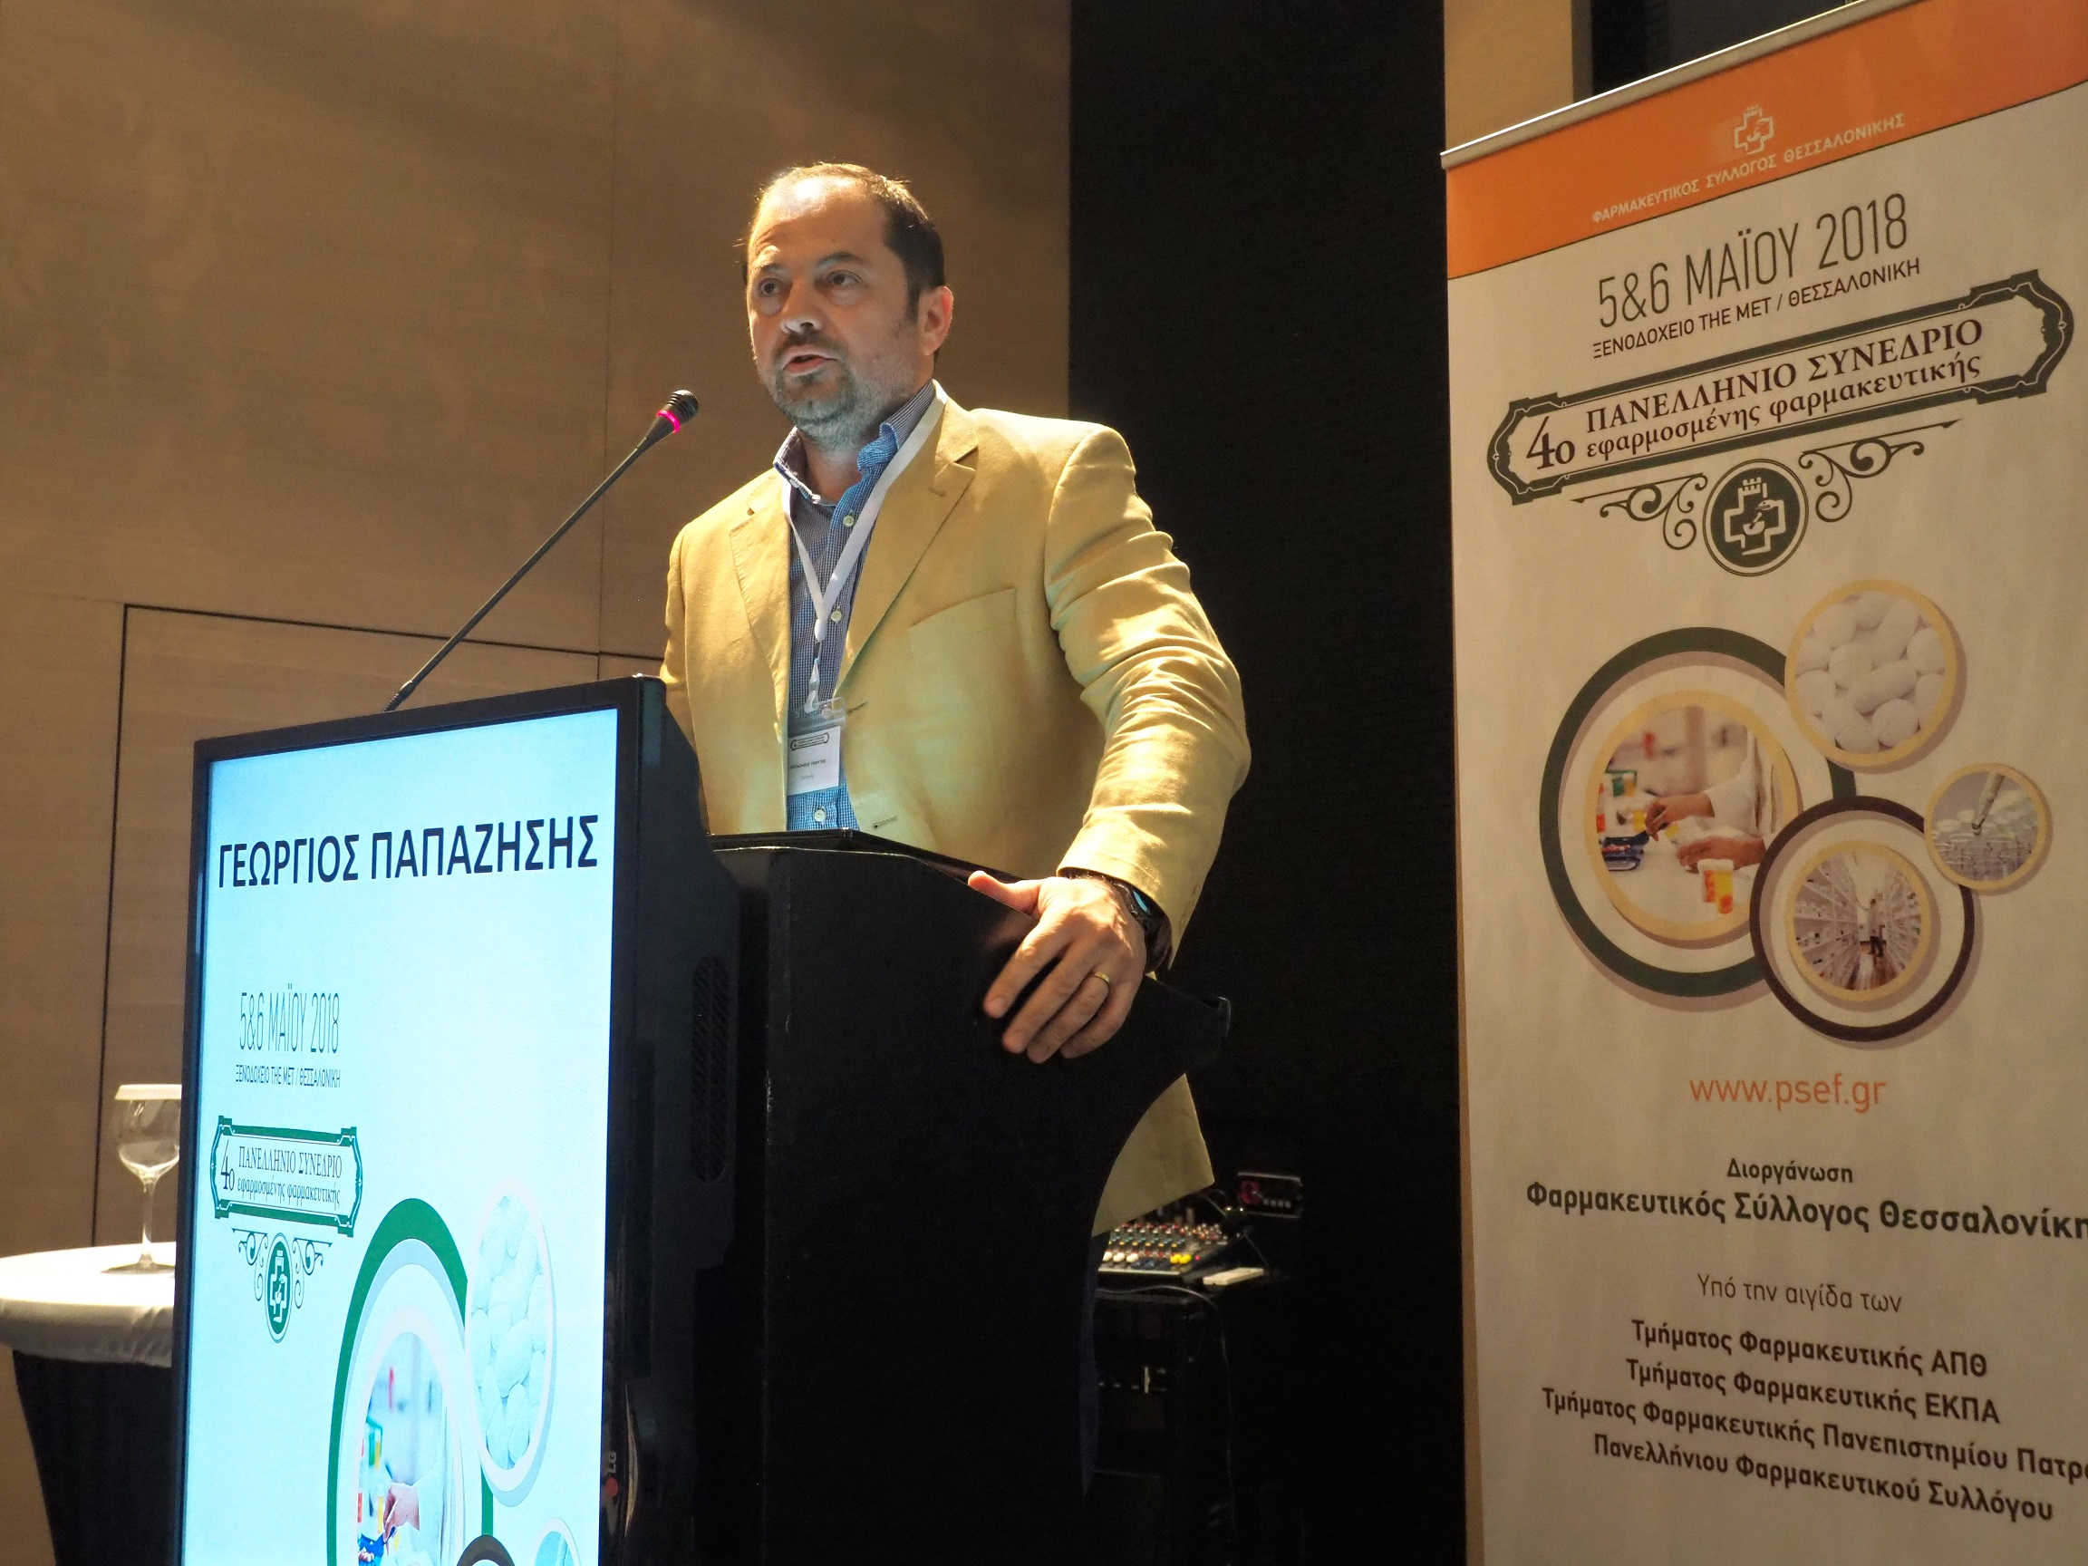 | P.Levanti 3, 54636 Thessaloniki, Greece
 | +302310999323 +306972213327
 | papazisg@auth.gr, georgepapaz@gmail.com
 | http://www2.med.auth.gr/depts/b-pharmacology/?q=users/gpapaz
 | Sex Male Date of birth 08/02/1974 Nationality Greek

POSITIONS (professional) | - Associate Professor of Pharmacology and Clinical Pharmacology, Department of Clinical Pharmacology, Faculty of Medicine, Aristotle University of Thessaloniki

POSITIONS (regulatory) | - Health Technology Assessment Committee (HTA), Ministry of Health, Greece: member  - European Medicines Agency (EMA): National Representative Observer at the Central Nervous System Working Party  - Illicit drug committee, Ministry of Health, Greece: member  - Greek National Organization for Medicines (EOF): member of the Second Degree Scientific Advisory Board  - Greek National Organization for Medicines (EOF): external expert of the Pharmacovigilance department (clinical assessment in signal management)

Current research Projects | - Conect4children (c4c): Greek National Hub Pharmacovigilance representative https://conect4children.org  - Horizon2020 Justice Programme ‘JUSTSO’: Analysis, Knowledge dissemination Justice implementation and Special Testing of novel Synthetic Opioids. (principal investigator for Greece) https://justso-eu.eu  - Multicenter clinical trial NL69565.068.19: Validating reward-related biomarkers to facilitate development of new treatments for anhedonia and reward processing deficits in schizophrenia and major depressive disorder (RTOC)’ (principal investigator for Greece)  - Horizon 2020 PCP funded project ‘Relief’ (Medical advisor)  - International Network for Cannabis Assessment (INCA): Secondary Proposer at the COST 2020 action

MEMBERSHIPS (active) | - Treasurer of the Hellenic Society of Pharmacology and Clinical Pharmacology  - Member of the Human Experimental Medicine Network of the European College of Neuropsychopharmacology  - Member of the ‘Evidence Based Psychiatry’ section of the World Psychiatric Association  - Member of the Deutsche Arbeitsgemeinschaft für Neuropsychopharmacologie und Pharmacopsychiatrie (DGNP)  - Member of the European Association of Clinical Pharmacology&Therapeutics  - Member of the International Society of Pharmacovigilance

WORK EXPERIENCE
Dates | 2013-present
Occupation or position held | Associate Professor of Pharmacology and Clinical Pharmacology
Main activities and responsibilities | Experimental and Clinical pharmacology
Name and address of employer | Department of Clinical Pharmacology, School of Medicine, Aristotle University of Thessaloniki
Type of business or sector | University

Dates | 2009-2013
Occupation or position held | Lecturer of Pharmacology and Clinical Pharmacology
Main activities and responsibilities | Experimental and Clinical pharmacology
Name and address of employer | Department of Clinical Pharmacology, School of Medicine, Aristotle University of Thessaloniki
Type of business or sector | University
Dates  Occupation or position held  Main activities and responsibilities  Name and address of employer  Type of business or sector | 2009-2010  Visiting Lecturer  Teaching Pharmacology and Psychiatry  Department of Nursing, Frederick University, Nicosia, Cyprus  University
Dates | 2008-present
Occupation or position held | Psychiatrist
Main activities and responsibilities | Treating psychiatric patient. Psychopharmacology and Cognitive-Analytic Psychotherapy
Type of business or sector | Private Practice
Dates | 2005-2009
Occupation or position held | Research Fellow
Main activities and responsibilities | Teaching Psychiatry, Neurology and Neurophysiology
Name and address of employer | Department of Nursing and Department of Physiotherapy, School of Health and Medical Care, Thessaloniki, Greece
Type of business or sector | Technological Educational Institute
Dates | 2003-2008
Occupation or position held | Resident in Psychiatry
Name and address of employer | Psychiatric Hospital of Thessaloniki, Greece
Type of business or sector | Psychiatric Hospital
Dates | 1998-2000
Occupation or position held | Medical Doctor
Name and address of employer | Community Health Center Livadi Elassonas, Greece
Type of business or sector | Community Practice

EDUCATION AND TRAINING
Dates |  | 2003-2008
Title of qualification awarded |  | Greek Board Certified in Psychiatry
Principal subjects/occupational skills covered |  | Psychiatry-Psychotherapy. Specialization in Psychopharmacology and Cognitive-Analytic Psychotherapy
Name and type of organisation providing education and training |  | Psychiatric Hospital of Thessaloniki
Dates |  | 2000-2005
Title of qualification awarded |  | PhD degree in Pharmacology/Physiology
Principal subjects/occupational skills covered |  | Experimental model. Evaluation of neuroprotective agents in hypoxic-ischemic encephalopathy
Name and type of organisation providing education and training |  | School of Medicine, Aristotle University Thessaloniki, Greece
Dates |  | 1992-1998
Title of qualification awarded |  | Medical Doctor
Name and type of organisation providing education and training |  | School of Medicine, Aristotle University Thessaloniki, Greece

Organisational / managerial skills | - Member of organising and scientific committees of Greek and international conferences  - Principal Coordinator of EU funded projects and clinical trials

Research experience to date  Current research Interest | - 2011- present: Research Committee of the Aristotle University of Thessaloniki, "Continuous Education in Clinical Pharmacology” (Project No 87676). Position: Coordinator  - 2015-present: Research Committee of the Aristotle University of Thessaloniki, ‘Consulting and technical services in pharmacology-toxicology and clinical pharmacology’ (Project No 92198). Position: Coordinator  - 2014-present: Member of the Human Experimental Medicine Network of the European College of Neuropsychopharmacology  - 01/05/2008-30/04/2011: Participant of the CORDIS-FP7 Specific Programme project: ‘Centre for pre-clinical testing of active substance-CPCTAS’. Position: Quality control and monitoring report  - 24/03/2010-12/04/2010: Clinical Rotation focused on Clinical Pharmacology and Clinical Research, Beth Israel Deaconess Medical Center, Harvard Medical School, Boston, MA  - Pharmacovigilance  - Psychotropic drug safety  - Patient Safety  - Novel synthetic opioids  - Prevalence of antenatal depression among women with high risk pregnancies  - Prevalence of perimenopausal depression in Greece

Publications  Ad-hoc reviewer  Awards | - PubMed papers: https://www.ncbi.nlm.nih.gov/pubmed/?term=Papazisis+g  - Book Chapters: 3 (2 international, 1 Greek)  - Indexed Abstracts: over 100 (published in Scopus, ISI Web of Science, Google Scholar https://scholar.google.com/citations?hl=en&user=1YwtMGEAAAAJ)  - Citations: >1450, h-index:23  ORCID: https://orcid.org/0000-0003-1641-9095  - Biological Psychiatry  - The International Journal of Neuropsychopharmacology  - Progress in Neuropsychopharmacology and Biological Psychiatry  - Journal of Clinical Psychiatry  - Psychiatry and Clinical Neuroscience  - Brain Research Bulletin  - The Journal of Neuropsychiatry and Clinical Neurosciences  - Clinical Schizophrenia & Related Psychoses  - Hippokratia  - Biologics: Targets and Therapy  - Drugs of Today  - Journal of Medical Case Reports  - Psychiatrica danubina  - Faculty of Medicie, AUTH (2019): Award for Mentoring PhD in German University  - Faculty of Medicine, AUTh (2017): Award for excellence in teaching  - AUTH research committee (2014): research grant for the project: ABCB1 polymorphisms and therapeutic response to antipsychotics in schizophrenic patients in Greece  - Educational grand for the ECNP School of Neuropsychopharmacology, Oxford, United Kingdom, 2012  - Educational grand for the ECNP Workshop on Neuropsychopharmacology for Young Scientists in Europe, Nice, France 2009  - Educational grand for the ECNP Workshop on Neuropsychopharmacology for Young Scientists in Europe, Nice, France 2006

