

THE FEDERAL STATE BUDGET EDUCATIONAL INSTITUTION OF HIGHER EDUCATION

“STAVROPOL STATE MEDICAL UNIVERSITY“ OF THE MINISTRY OF HEALTH OF THE RUSSIAN FEDERATION

Council of Young Researches and Students’ Scientific Society

All India Foreign Medical Graduates Association

A. J. Trust Educational Consultancy

Enter Contact Information Here | 1127 Lombard Blvd. San Francisco, CA 59802 | phone 555.555.5555 | fax 555.555.5555

­

International participants – Submission is free

**FEES OF PARTICIPATION**

**CONTACTS**

**Dr. Murugesan Suresh**

Ph: +919952435776; +7-988703-42-21;

E-mail: sureshmuthu2003@yahoo.co.in

**Prof. Stoyana Znamenskaya**

Ph: +7-962403-46-41;

E-mail: dekins@stgmu.ru (For Conference in English)

**dEAN OF FOREIGN STUDENTS’ FACULTY**

**prof. S.v. znamenskaya**

Every International participant will receive special certificate from our University and an abstract book.

To participate in the conference one should fill and send the *Application Form* with name and address to one of the corresponding e-mail addresses dekins@stgmu.ru; sureshmuthu2003@yahoo.co.in (For Conference in English) ***no later than March 20, 2017.***

***Please, send us the filled Application Form (Example):***

|  |  |
| --- | --- |
| *Name* | *Igor Ivanov* |
| *Organization* | *Stavropol State Medical University* |
| *Position* | *Postgraduate, Obstetrics*  *and Gynaecology Department* |
| *Scientific degree* | *–* |
| *Phone* | *+7-999-766-88-99* |
| *E-mail* | *ivanov@mail.ru* |
| *Section (choose one)* | *Topical Issues of*  *Obstetrics and Gynaecology* |
| *Form of participation* | *1. Oral presentation with publication* |

**iNTERNATIONAL PARTICIPATION**

1. Oral presentation with publication of abstract
2. Only publication of abstract without participation
3. Poster presentation

***You may take part in the following sections*:**

* Topical issues of Biophysics, Biochemistry, Biotechnology and Biomedical Engineering;
* Topical issues of Medical and Biologic Sciences;
* Topical issues of Therapy, Pediatrics;
* Topical issues of Surgery, Obstetrics and Gynaecology;Topical issues of Dentistry;
* Topical issues of Public Health.

**Mode of participation**

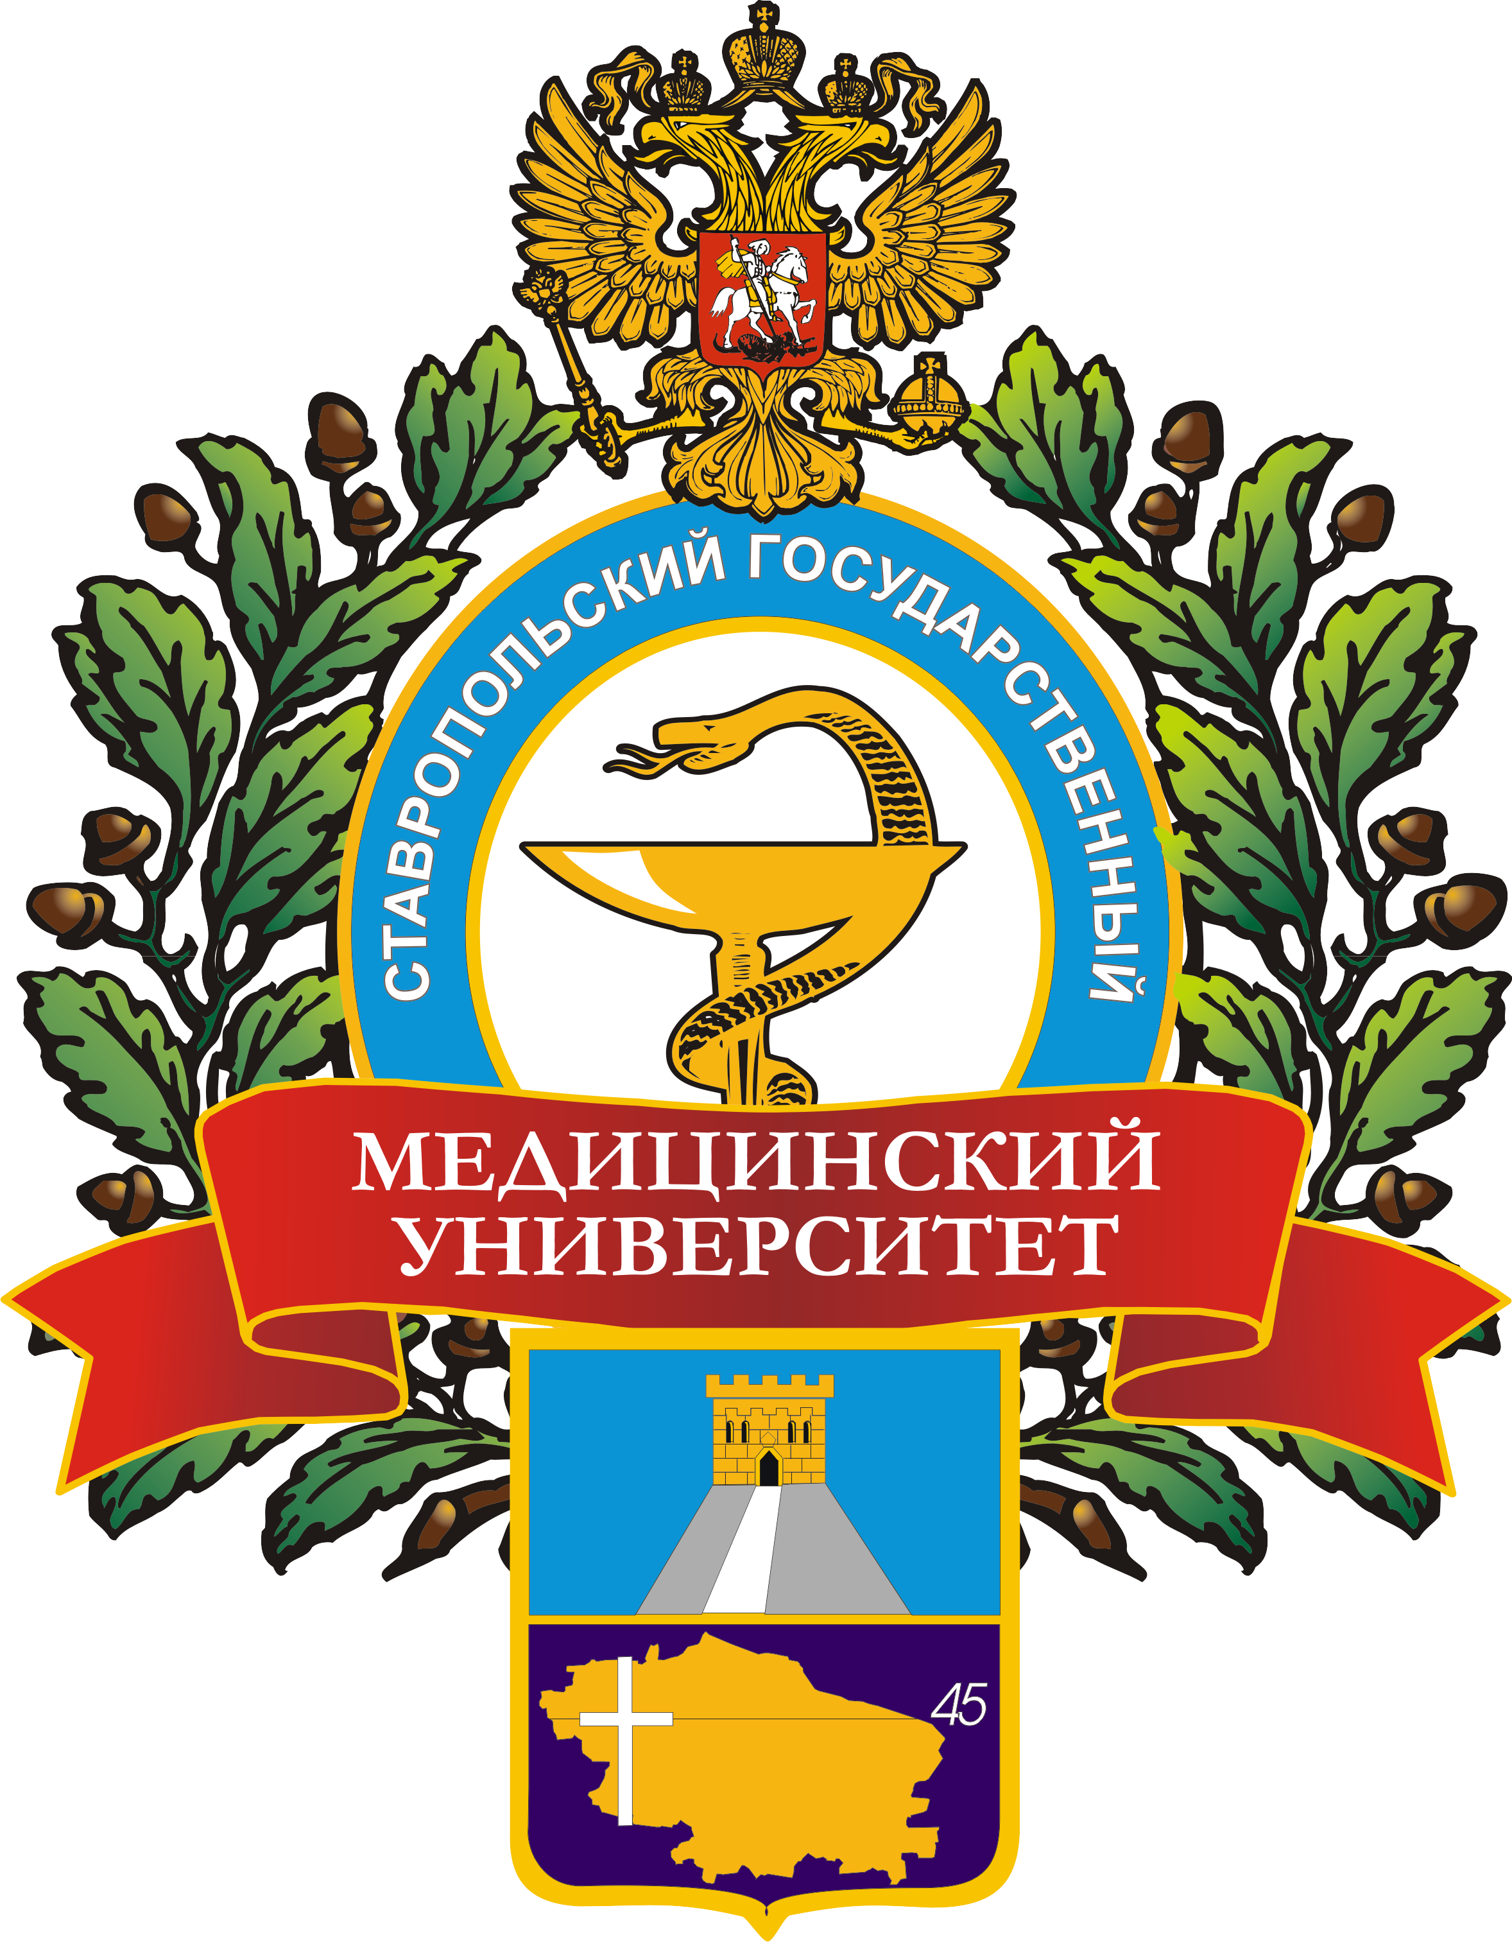 

**NECESSARY INFORMATION**

**FOR AUTHORS**

Only original abstracts will be accepted for publication till ***March 20, 2017.***

*The volume* of the abstract should not exceed 1 page (A4, 210x297 mm), Font - Times New Roman, 12th size, 1.5 spacing.

*The title* of the article (abstract) (in bold capital letters) should include: 1) the first and second name of the author (the number of co-author is limited up to 5 persons) in bold italic; 2) organization name, city and country; 3) scientific supervisors with indicating a degree and position.

*The abstract* should include the following items:

1) background; 2) objective; 3) materials and methods; 4) results and discussion; 5) conclusion; 6) keywords.

*The number of abstracts for one author is limited for 3.*

THE INTERNATIONAL SCIENTIFIC CONFERENCE FOR STUDENTS AND YOUNG RESEARCHERS IN ENGLISH **«TOPICAL ISSUES OF MEDICINE»**

**DEAR COLLEAGUES!**

We invite you to take part in work of the International Scientific Conference for Students and Young Researchers in English

**«**TOPICAL ISSUES OF MEDICINE» on ***April 27, 2017***

(310, Mira str., Stavropol, Russia, 355017).

**iNVITATION**

**Interested students may enquire about the conference program from Scientific Committee Members**