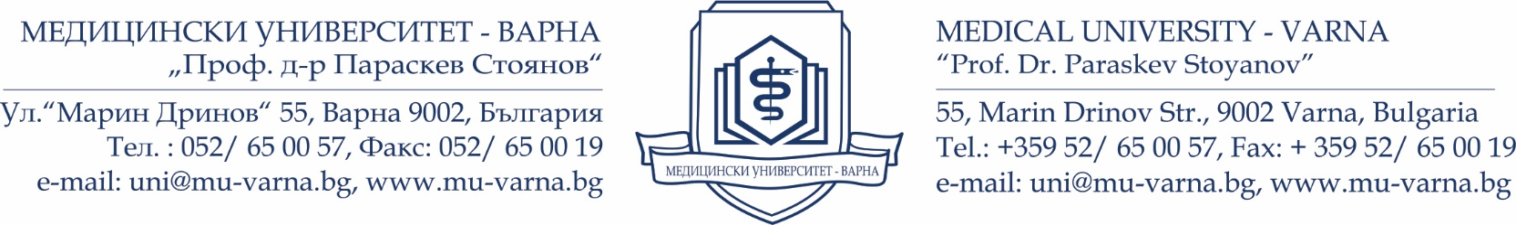
SECOND NATIONAL STUDENTS’ FESTIVAL OF MEDICAL UNIVERSITIES
April 2018
Medical University “Prof. Dr. Paraskev Stoyanov” – Varna

Dear colleagues,

It is our pleasure to invite your medical students to The Second National Students’ Festival of the Medical Universities, which will take place on 20-22 April 2018 in the Wellness and Health Complex “Kamchia”, Varna, Bulgaria. It is one of the biggest university events in Bulgaria with international participation. The Second National Students’ Festival of the Medical Universities is hosted by Medical University – Varna.

The Festival is open for participation to medical universities from all over the world. Every university can participate with five performances, 2-5 minutes each, with a maximum of 10-12 participants. Performances can be individual or group, in the field of music or dancing.
Participation fee in the Festival scheduled programme is 50 € per one person, including accommodation costs for 3 nights (Wellness and Health Complex “Kamchia”), breakfast, lunches, dinners and cultural programme. Participants are responsible for covering their travel costs and making the respective travel arrangements. Additional fee may be required for extra nights at the hotel.

To facilitate the logistical organization, please fill in the attached registration form and return it to international_relations@mu-varna.bg by 29th December 2017. For the selection procedure, we require a short demo version of your performance accompanying the completed registration form.

The team of the Department of International Relations will be glad to assist you and
provide additional information on the following e-mail: international_relations@mu-varna.bg

Looking forward to meeting you in Varna!

Best regards,

The team of the International Relations Department
Medical University of Varna
55 “Marin Drinov” Str.
Varna 9002, Bulgaria

